8. PROJECT DEMONSTRATION PHASE
8.1 Introduction
The Project Demonstration Phase is the final stage of the AI FAQ Assistant AI project. In this phase, the completed application is demonstrated practically to show the working of its major modules.
The project is executed using Node.js and Express.js, with MongoDB for database management and Gemini AI for AI-based FAQ and answer generation. Thunder Client is used to test and display the API requests and responses.

8.2 Project Execution
The project is opened in Visual Studio Code and the Node.js server is started. The connection with MongoDB is verified before testing the APIs.
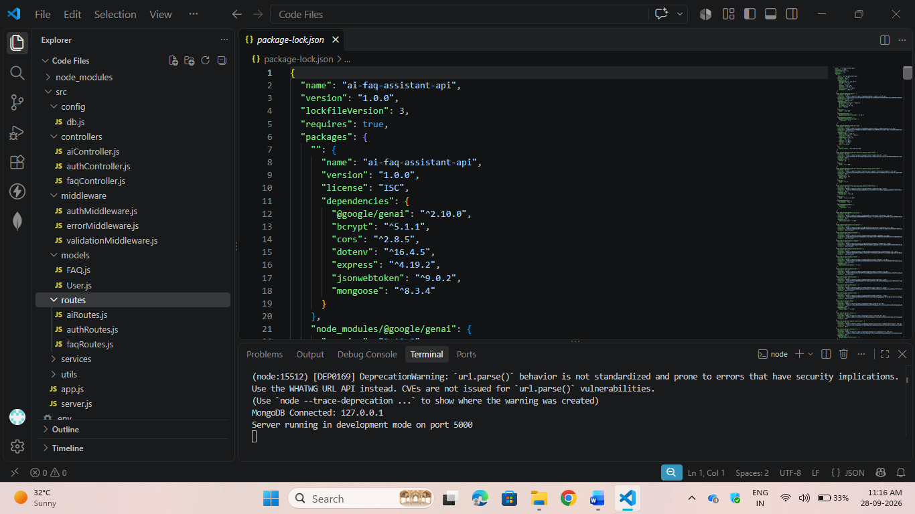
The successful server execution confirms that the backend is ready to process requests.

8.3 User Registration and Login
The registration API is tested by entering the required user details. After successful registration, the user logs in using the registered credentials.
A JWT token is generated after successful login and is used for accessing protected
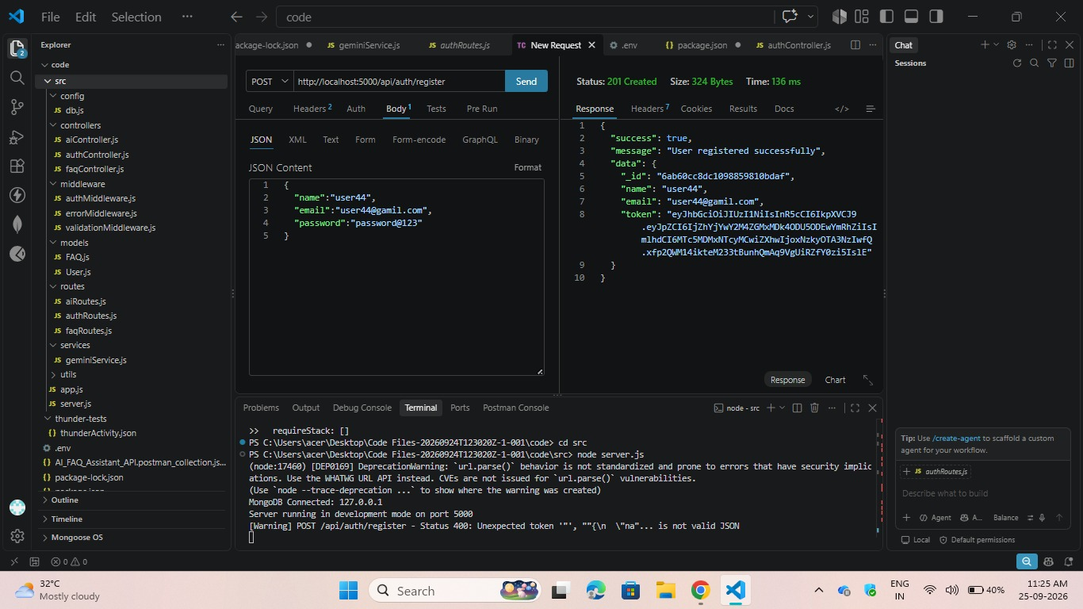
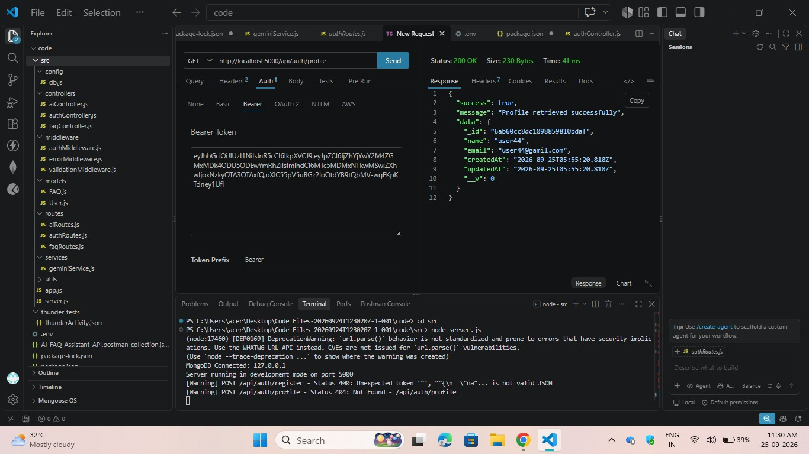

8.4 FAQ and AI Generation
The FAQ API is tested using Thunder Client. The required input is provided and the server returns the FAQ response.
The AI FAQ Generation feature sends the given topic to Gemini AI and receives AI-generated FAQ content.
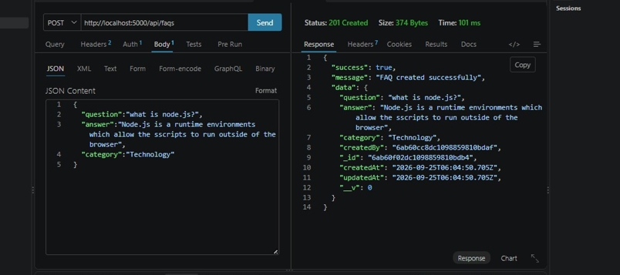

8.5 AI Answer Generation
A question is provided through the AI Answer Generation API. The backend sends the question to Gemini AI and receives an AI-generated answer.
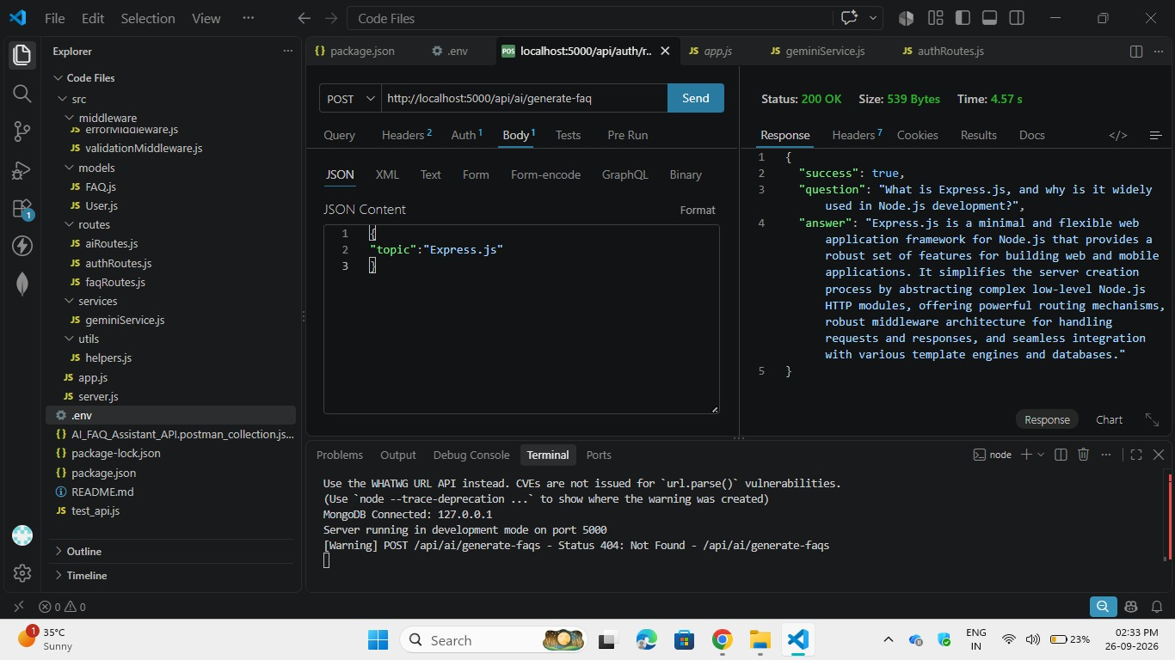
8.6 Final Output
The generated FAQ and user data are successfully stored in the MongoDB database and can be viewed after project execution.
The MongoDB database confirms that the AI FAQ Assistant AI project has successfully completed its data storage and processing operations.


